Data Analysis Report

Project ID: 78G0OL
Dataset: Amazon Sales Data
Prepared by: Abhay Sharma
Date: 6-Oct-2026

Table of Contents
1. Executive Summary 3
2. About the Project and the Data 4
2.1 The problem 4
2.2 The data 4
2.3 How revenue is counted 4
3. Data Preparation 4
4. Analysis and Findings 5
4.1 Sales Overview 5
4.2 Product Analysis 7
4.3 Fulfilment Analysis 8
4.4 Customer Segmentation 9
4.5 Geographical Analysis 10
5. Recommendations 11
5.1 Sales 11
5.2 Inventory 12
5.3 Customer Service 12
6. Limitations 13
7. Conclusion 13
Appendix A: Interactive Power BI Dashboard 14
A.1 Page 1: Sales overview 14
A.2 Page 2: Fulfilment, customers and regions 15
A.3 How to use it 15

1. Executive Summary
This report looks at 128,976 order lines from an Amazon.in apparel and accessories seller, covering 31 March to 29 June 2022. It checks how sales moved over time, which products sell, how well the two fulfilment methods work, what kinds of buyers there are, and where in India the orders come from. It closes with practical recommendations.

₹71.7 million  Total revenue (about ₹7.17 crore) | 100,600  Orders (not cancelled) | 108,481  Items sold
₹712  Average value per order | 14.2%  Order lines cancelled | 91%  Revenue from T-shirts, Shirts and Blazers

The main findings
- Sales are slowing. Revenue fell from ₹26.2 million in April to ₹24.0 million in May and ₹21.4 million in June. Orders dropped by about 23% over that time, while the average order grew slightly.
- Three products carry the business. T-shirts (49.9%), Shirts (27.1%) and Blazers (14.2%) bring in 91% of revenue. Blazers are the fastest riser, going from 10% of revenue in April to 17% in May and June.
- Mid sizes dominate. M, L and XL make up half of all items sold. The largest sizes (4XL to 6XL) are only 1.4%.
- Merchant-fulfilled orders perform worse. 17.5% of them are cancelled, against 12.8% for Amazon-fulfilled orders, and about 5% are returned or rejected.
- Sales are concentrated. Maharashtra, Karnataka and Telangana give 39% of revenue, and ten cities give 44%. Several large states, such as Gujarat, Rajasthan and Bihar, sell very little by comparison.
- Cancellations are expensive. Where an amount was recorded, cancelled orders were worth about ₹6.9 million, roughly one tenth of the revenue actually earned.

2. About the Project and the Data

2.1 The problem
The task is to analyse an Amazon sales report and turn it into advice the business can act on. The brief lists six objectives:
- Sales overview: how sales change over time.
- Product analysis: which categories, sizes and quantities are popular.
- Fulfilment analysis: how well each fulfilment method works.
- Customer segmentation: grouping buyers by behaviour and location.
- Geographical analysis: how sales spread across regions.
- Business insights: recommendations for growth.

2.2 The data
The file has 128,976 rows and 21 columns. Each row is one order line, meaning one product on one order. A few orders contain more than one line, so there are 120,229 distinct order IDs. The columns cover order date, status, fulfilment method, shipping level, product category, size, quantity, amount in INR, the shipping city and state, and whether the buyer is a business (B2B).
The analysis was done in Python (pandas for the calculations, matplotlib for the charts), and the report was written in Word. An interactive dashboard was also built in Power BI from the same cleaned data (see Appendix A).

2.3 How revenue is counted
Revenue in this report means the total Amount on order lines that were not cancelled and had a value above zero. Cancelled orders are studied separately in the fulfilment section.

3. Data Preparation
The raw file needed some tidying before the numbers could be trusted. The table lists what was found and what was done.
Issue | What was found | What was done
Useless columns | "index" is only a row number. "New" and "PendingS" are completely empty. | Removed all three.
Dates | Stored as text in month-day-year form. | Converted to real dates. The data runs from 31 March to 29 June 2022.
Spelling and names | The category "Blazzer" is misspelt, and the "Sales Channel" column name had a trailing space. | Corrected both.
State names | 69 different spellings, e.g. "Delhi", "DELHI", "New Delhi", "RJ", "Rajshthan", "Orissa". | Standardised to 37 states and territories. Main city variants (e.g. Bangalore and Bengaluru) were merged too.
Missing amounts | 7,800 rows have no amount or currency. 7,571 of them are cancelled orders. | Left out of revenue.
Zero amounts | 2,343 shipped rows show an amount of 0 (possibly free or promotional items). | Left out of revenue.
Cancelled orders | 18,334 order lines (14.2%) are cancelled. | Kept for the cancellation analysis, left out of revenue and product sales.
Missing location | 35 rows have no city or state. | Left out of the location charts only.

After cleaning, 108,070 order lines (100,600 orders) were used for the revenue analysis, and all 128,976 lines were used for status and cancellation figures.

4. Analysis and Findings

4.1 Sales Overview
Revenue was highest in April and has fallen in each month since. March is left out of the monthly chart because the data holds only one day of it (31 March).
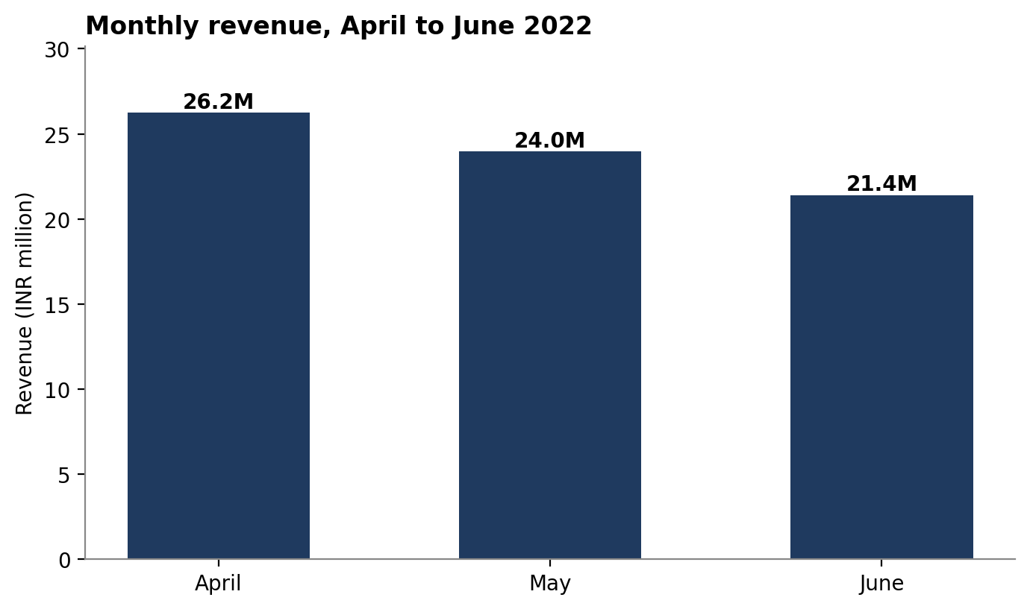
Figure 1. Monthly revenue, April to June 2022
May revenue was 8.7% below April, and June was a further 10.7% below May. This is not caused by months having different lengths: average revenue per day went from ₹874,000 in April to ₹773,000 in May and ₹738,000 in June.
The number of orders fell faster than revenue. Distinct orders went from 38,120 in April to 32,948 in May and 29,392 in June, a drop of about 23%. Revenue held up better because the average order grew from ₹688 to ₹728, mainly because more Blazers (a higher-priced product) were sold.

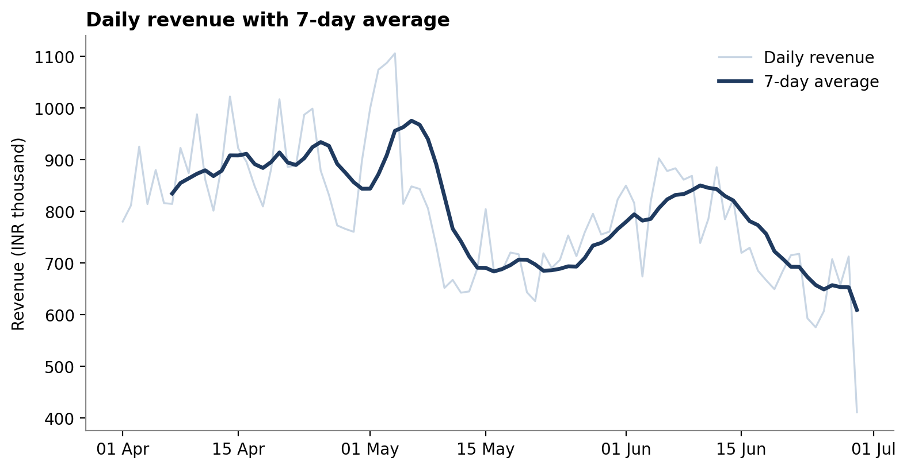
Figure 2. Daily revenue and its 7-day average
The daily chart shows the pattern in more detail. Sales ran at roughly ₹800,000 to ₹900,000 a day through April, then rose to a peak of about ₹1.1 million a day on 2 to 4 May. After that they dropped sharply, to around ₹690,000 a day by mid-May, recovered to about ₹840,000 in mid-June, and slid again to about ₹650,000 by the end of June. The very last day (29 June, ₹410,000) looks like a partial day and should not be read as a real fall.

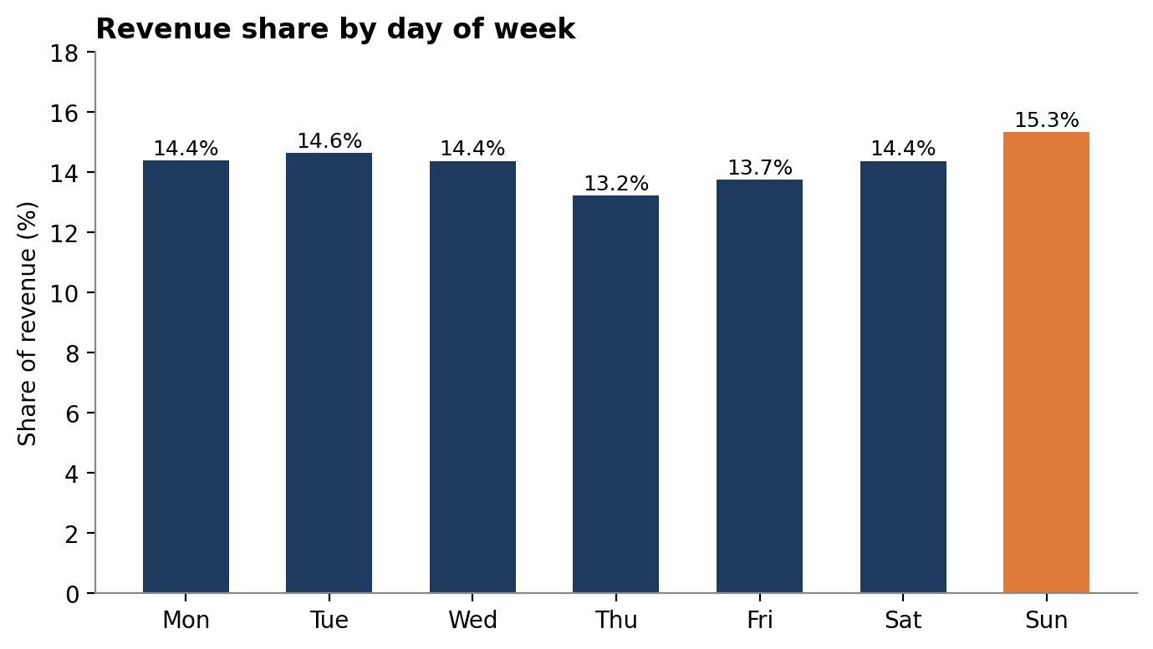
Figure 3. Share of revenue by day of week
Day of the week makes only a small difference. Sunday is the strongest day (15.3% of revenue) and Thursday the weakest (13.2%), but the gap is small, so weekday timing is not a major lever.

4.2 Product Analysis
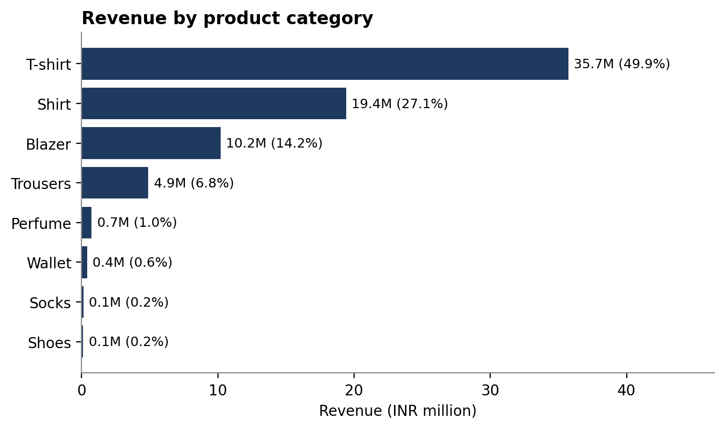
Figure 4. Revenue by product category
T-shirts alone bring in almost half of all revenue (₹35.7 million, 49.9%). Shirts add 27.1% and Blazers 14.2%, and the first three together make up 91.2%. Trousers give another 6.8%. Perfume, Wallet, Socks, Shoes and Watch are about 2% combined, and the Watch sold only three times in three months.
T-shirts and Shirts sell in almost identical numbers (about 42,000 items each), but the T-shirts earn far more because of price: roughly ₹850 per T-shirt against ₹465 per Shirt. The product mix is also changing. Blazers grew from 10.2% of revenue in April to 16.6% in both May and June, while T-shirts slipped from 53.8% to 46.9%.
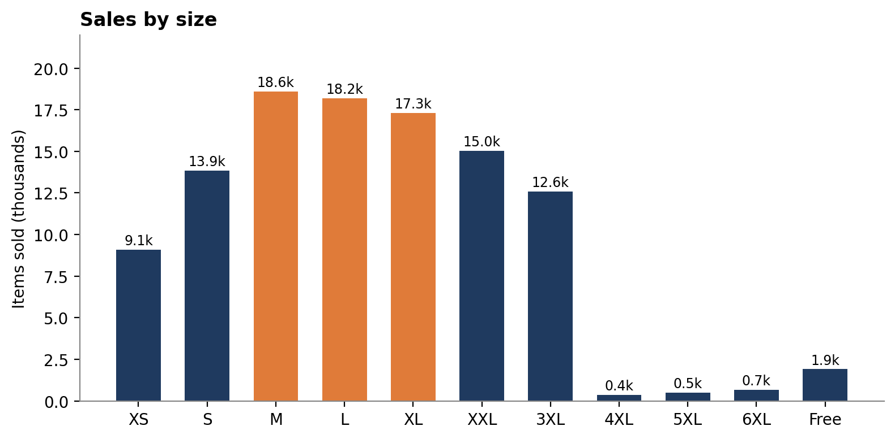
Figure 5. Items sold by size (M, L and XL highlighted)
Sizes M, L and XL together account for 50.1% of items sold. XXL (13.9%), S (12.8%) and 3XL (11.6%) come next, and XS is 8.4%. The very large sizes, 4XL, 5XL and 6XL, add up to only 1.4% and are mostly bought in Shirts. Perfume, Wallet, Shoes and Watch are sold in a single "Free" size. The best-selling size is M for T-shirts and L for Shirts and Blazers.
Almost every order line is for a single item. 99.7% of lines have a quantity of 1, and only about 6% of orders contain more than one line. Customers rarely buy several items at once.

4.3 Fulfilment Analysis
Two methods are used. With Amazon fulfilment, Amazon stores, packs and ships the item (69.6% of order lines). With Merchant fulfilment, the seller ships it through Easy Ship (30.4%). The table compares them.
 | Amazon | Merchant
Share of order lines | 69.6% | 30.4%
Revenue | ₹50.6 million (70.6%) | ₹21.1 million (29.4%)
Average value per item | ₹661 | ₹667
Cancellation rate | 12.8% | 17.5%
Returned, returning or rejected | Not recorded | 5.4%
Shipping level used | 99% Expedited | 100% Standard

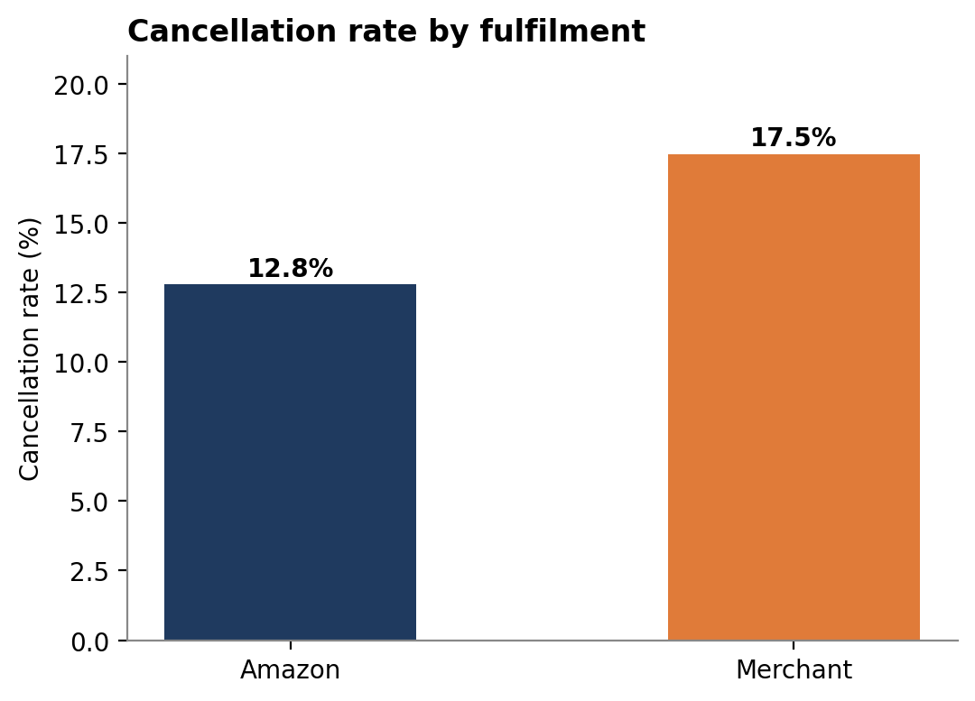
Figure 6. Cancellation rate by fulfilment method
Both methods sell at similar prices, so the difference is in reliability. Merchant orders are cancelled almost five percentage points more often. If Merchant had matched Amazon's cancellation rate, there would have been roughly 1,800 fewer cancelled lines, worth about ₹1.2 million at the average Merchant price. This is a rough estimate, since not every cancelled order could have been saved.
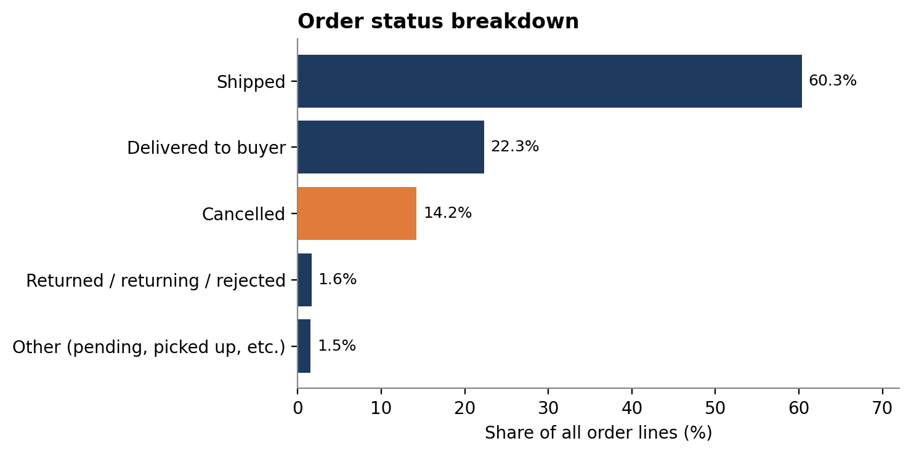
Figure 7. Status of all order lines
Overall, 60.3% of order lines show as shipped, 22.3% as delivered to the buyer, and 14.2% as cancelled. Returns, returning orders and rejections are a further 1.6%. All of those return-type statuses come from Merchant orders, where they make up about 5% (spread evenly across categories at roughly 5% to 6%, so it is not a problem with one product). Cancellations have stayed steady at 14.0% to 14.5% in each full month, so the problem is constant rather than getting worse.

4.4 Customer Segmentation
The dataset has no customer ID, so individual buyers cannot be followed over time. Buyers are therefore grouped by what they do: whether they are a business, how much they spend per item, and where they live (covered in the next section).
Business buyers. Only 798 items (0.7%) were bought by business (B2B) customers, worth ₹0.56 million, or 0.8% of revenue. They spend a little more per item than other buyers (₹701 against ₹663) and buy the same mix of T-shirts, Shirts and Blazers, mostly in Maharashtra and Uttar Pradesh. This segment is too small to matter yet, but it is untouched growth potential.
Spending groups. Every item sold was placed into one of three equal-sized groups by price: Low (up to about ₹500), Medium (about ₹500 to ₹735) and High (above about ₹735).
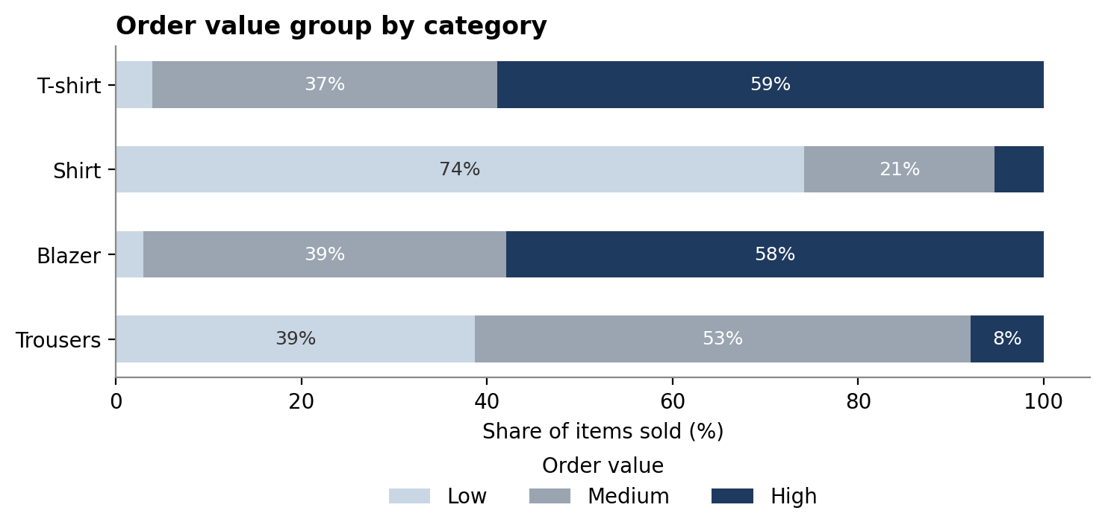
Figure 8. Spending groups within each main category

Group | Share of items | Typical price | What they mainly buy
Value shoppers | 34.6% | Up to ₹500 | Shirts (83% of this group)
Mid-range | 32.1% | ₹500 to ₹735 | T-shirts (45%), Shirts (25%), Blazers (15%), Trousers (14%)
Premium | 33.3% | Above ₹735 | T-shirts (69%) and Blazers (21%)

4.5 Geographical Analysis
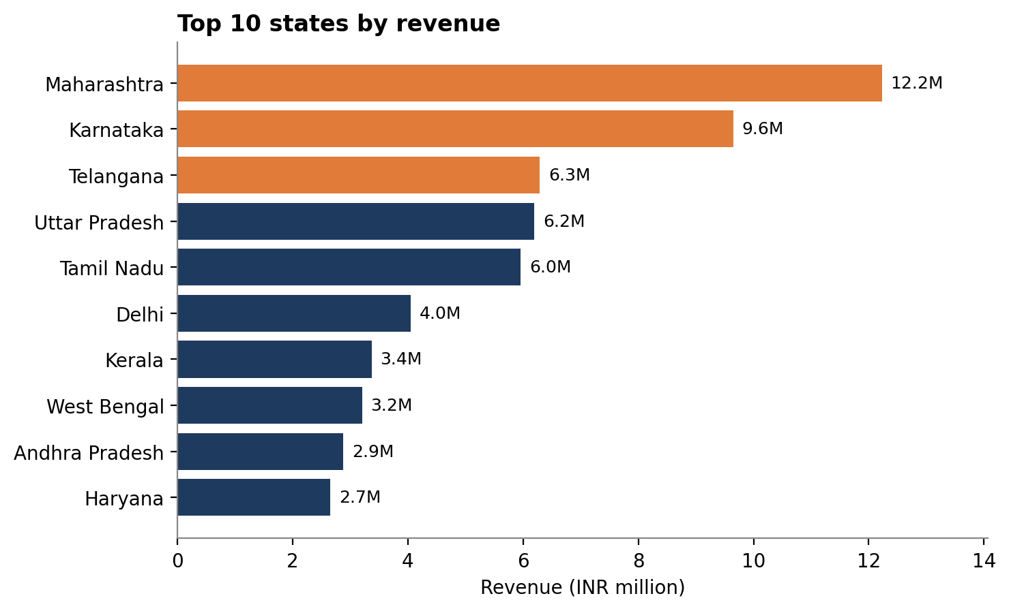
Figure 9. Top 10 states by revenue (top three highlighted)
Maharashtra leads with ₹12.2 million (17.1% of revenue), followed by Karnataka (₹9.6 million, 13.5%) and Telangana (₹6.3 million, 8.8%). Those three states give 39.3% of revenue, and adding Uttar Pradesh and Tamil Nadu brings it to 56.3%.
At the other end, the eight North-Eastern states together give only about 2.4% of revenue. More notable are several large states that rank low for their size: Gujarat (11th, ₹2.5 million), Rajasthan (12th, ₹1.6 million), Madhya Pradesh (13th, ₹1.5 million), Bihar (14th, ₹1.3 million), Odisha (15th, ₹1.2 million) and Punjab (16th, ₹1.1 million).
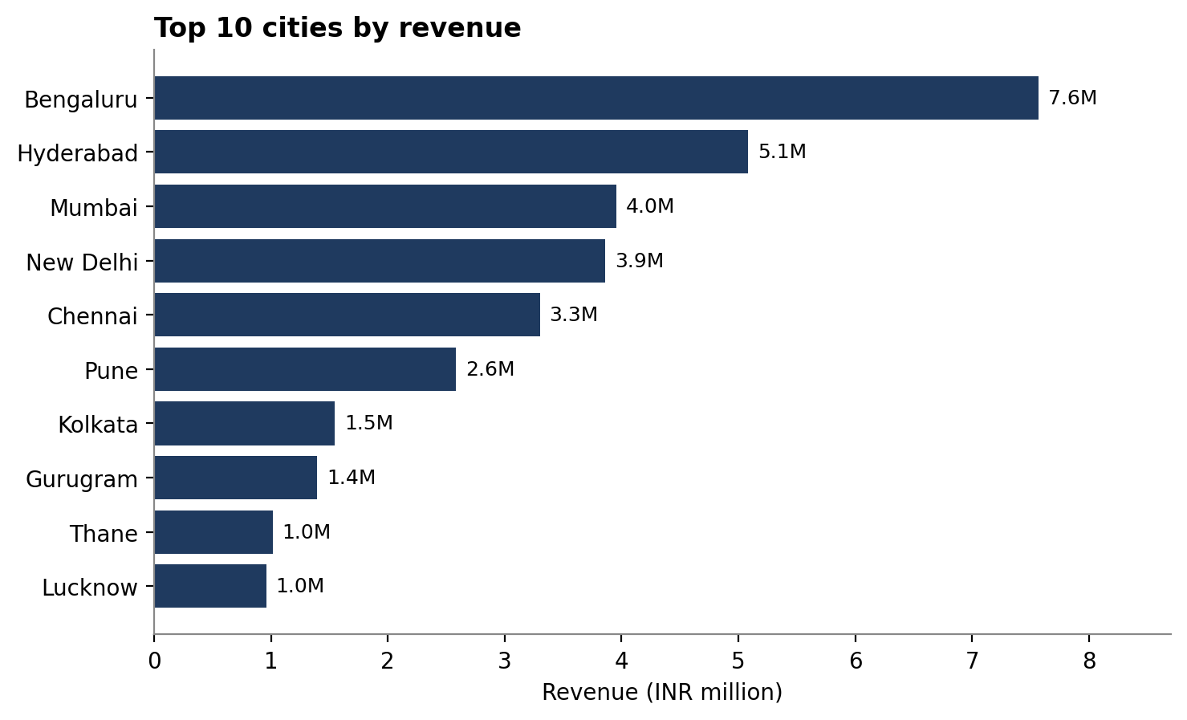
Figure 10. Top 10 cities by revenue
Bengaluru is the single biggest city at ₹7.6 million (10.6% of revenue), then Hyderabad (₹5.1 million), Mumbai (₹4.0 million), New Delhi (₹3.9 million) and Chennai (₹3.3 million). The top ten cities give 43.6% of revenue. City names in the raw data are inconsistent, so these figures are slightly on the low side.
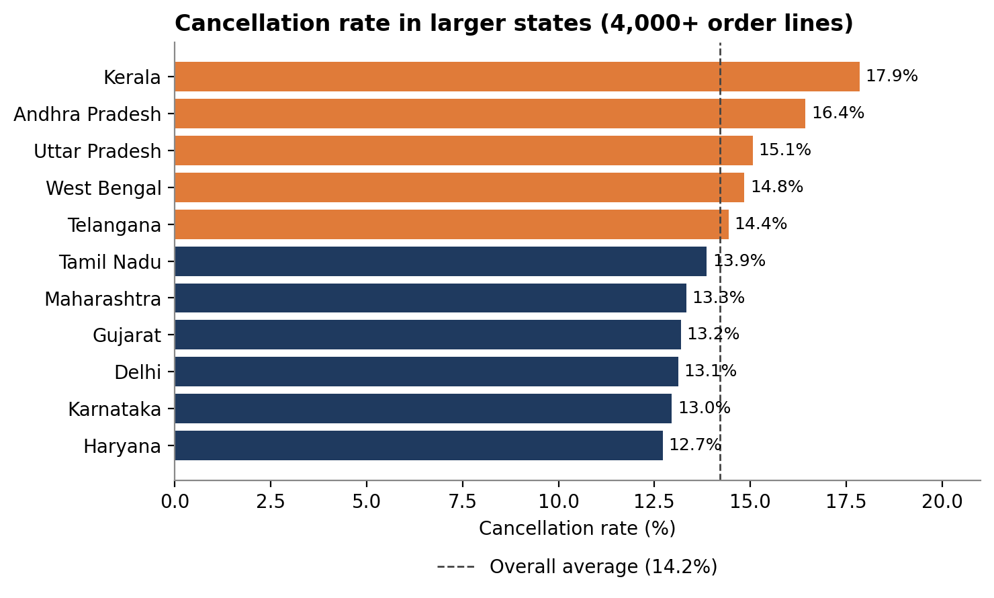
Figure 11. Cancellation rate in larger states (4,000 or more order lines)
Cancellation rates also differ by place. Among larger states, Kerala is highest at 17.9%, followed by Andhra Pradesh (16.4%), Uttar Pradesh (15.1%), West Bengal (14.8%) and Telangana (14.4%). Haryana (12.7%), Karnataka (13.0%) and Delhi (13.1%) are lowest. Kerala is high under both methods (20.0% for Merchant and 16.7% for Amazon), which suggests a delivery or buyer-behaviour issue in the region rather than a problem with one method.

5. Recommendations

5.1 Sales
- Find the cause of the decline. Review what happened around 2 to 6 May (the peak) and mid-May (the drop): offers, advertising, pricing and stock levels. Repeat whatever worked and fix whatever failed. Also compare with a longer history to see whether the slide is seasonal.
- Lean into Blazers. Their share rose from 10% to 17% of revenue and most are bought in the premium group. Widen the range and promote them more.
- Grow in under-served states. Run targeted campaigns in Gujarat, Rajasthan, Madhya Pradesh, Bihar, Odisha and Punjab, which are large states with relatively low sales.
- Sell more per order. Since 99.7% of lines are single items, offer bundles such as a T-shirt with Trousers, or a Shirt with a Wallet or Perfume. Perfume and Shoes sell at a high price per item but at tiny volumes.
- Look at B2B. Business buyers pay slightly more per item and make up almost nothing of sales today. Bulk pricing for small businesses is a low-cost test.

5.2 Inventory
- Stock deepest in M, L and XL. They are half of all items sold. Keep S, XXL and 3XL at moderate levels and XS lower.
- Keep the largest sizes lean. 4XL to 6XL sell only 1.4% of items and are bought mainly in Shirts, so small batches or made-to-order are safer than holding stock.
- Plan around demand, not April. April was the strongest month. Ordering stock based on it would over-stock a business that is now selling about 16% less per day.
- Place stock near the main cities. Bengaluru, Hyderabad, Mumbai, New Delhi, Chennai and Pune account for most revenue, so stocking close to them shortens delivery times.
- Review the long tail. Socks, Shoes and the Watch sell very little (the Watch sold three times). Either bundle them with top sellers or stop restocking them.

5.3 Customer Service
- Reduce Merchant cancellations. At 17.5% against 12.8% for Amazon, this is the clearest fixable problem. Move high-volume products to Amazon fulfilment, or tighten dispatch times and stock checks for Merchant orders. Closing the gap would save roughly ₹1.2 million.
- Look closely at Kerala and Andhra Pradesh. Their cancellation rates are 17.9% and 16.4%. Ask courier partners and customers why orders fail there. The reasons are not in the data.
- Handle returns. About 5% of Merchant orders come back. Returns are similar across every category, so improve packing and delivery checks rather than changing products. The small sizes (XS and S) have slightly higher return rates (about 6%) than L to XXL (about 5%), so clearer size guides on those listings may help.
- Track returns for Amazon-fulfilled orders too. The current data cannot show them, which hides part of the customer-service picture.

6. Limitations
- Short period. Three months is too short to separate real trends from seasonality.
- No customer ID. Repeat buying and loyalty cannot be measured.
- Revenue includes later returns. Orders that were returned after shipping (about 1.6% of lines) still count in revenue, so true net revenue is slightly lower.
- No costs or profit. The advice is based on sales, not margins.
- No cancellation reasons. The data shows how many orders were cancelled, but not why.
- Partial days. 31 March and 29 June are incomplete days, so they were handled with care in the trend charts.

7. Conclusion
The business sells a narrow range well. T-shirts, Shirts and Blazers bring in 91% of revenue, mid sizes dominate, and sales come mostly from the south and west. The warning sign is the steady fall in monthly sales since early May, together with a cancellation rate of 14% that is highest for Merchant-fulfilled orders and in states such as Kerala.
The practical path is straightforward: fix Merchant cancellations, find out what drove the early-May peak and the slide after it, grow Blazers, and open up the large states where sales are still small. Each of these comes directly from the numbers above, and the first one can be acted on immediately.

Appendix A: Interactive Power BI Dashboard
To go with the written analysis, a two-page dashboard was built in Power BI from the same cleaned data. It lets a manager explore the figures without reading the whole report. Every card and chart responds to the filters on the page (month, product category, fulfilment method and buyer type), and the filters carry over from one page to the other.

A.1 Page 1: Sales overview
The first page shows the headline figures as cards (revenue, orders, items sold, average order value and cancellation rate), followed by monthly revenue, daily revenue, revenue by category and items sold by size. It answers the question "how are we selling, and what is selling?"

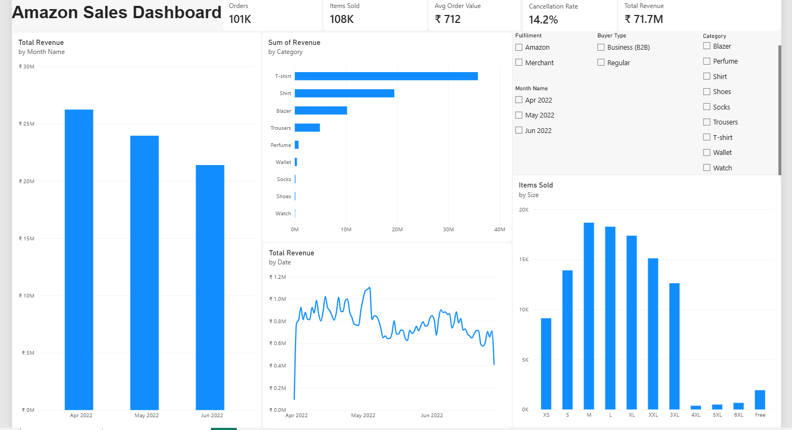

Figure 12. Power BI dashboard, page 1: sales overview

A.2 Page 2: Fulfilment, customers and regions
The second page covers cancellation rates for Amazon and Merchant fulfilment, the Merchant return rate, the revenue share of Amazon and business buyers, cancellation rates by state, spending groups by category, order status and the top cities. It answers "where do we lose orders, and who buys what?"

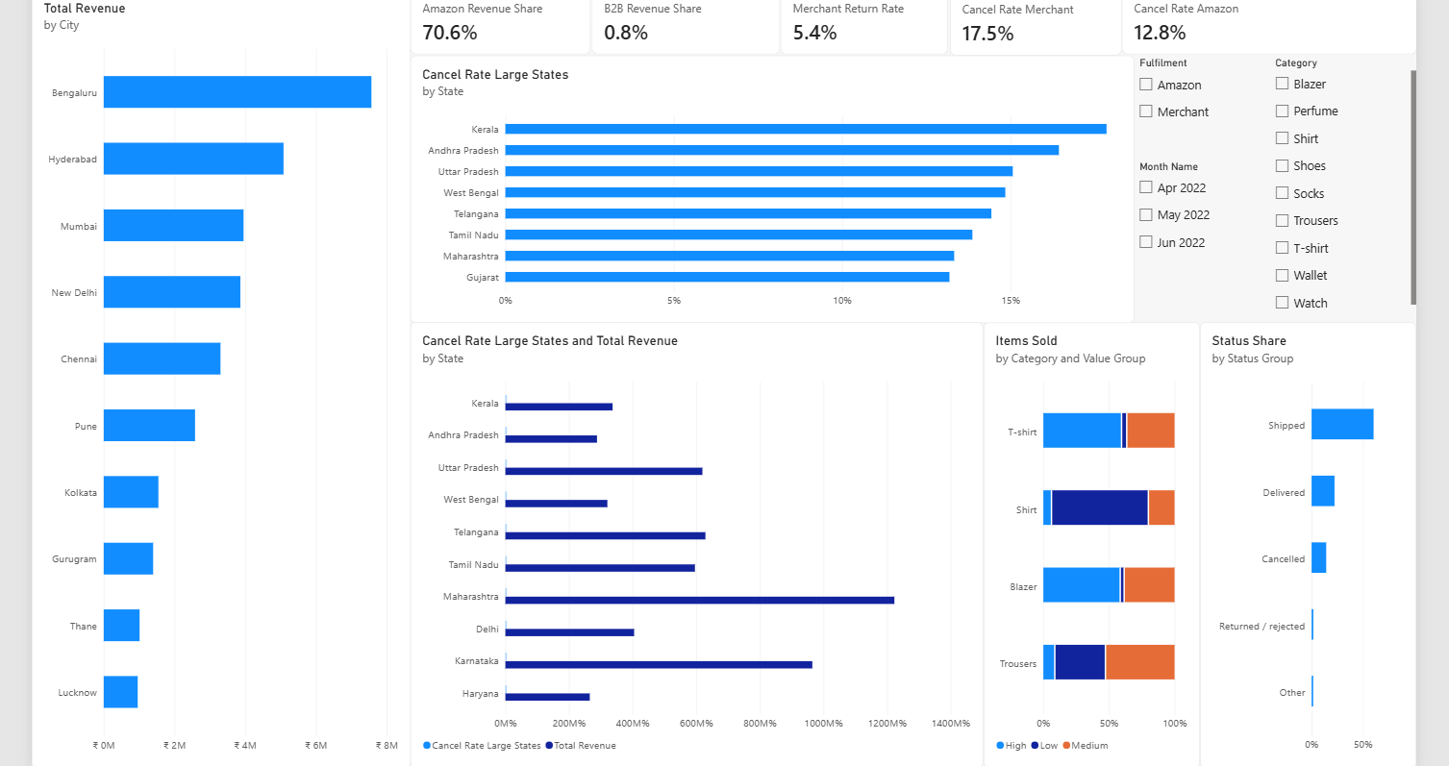

Figure 13. Power BI dashboard, page 2: fulfilment, customers and regions

A.3 How to use it
- Tick a month, category, fulfilment method or buyer type in the filter boxes, and every chart on both pages updates.
- Selecting Merchant in the fulfilment filter, for example, lifts the cancellation rate card to about 17.5%, and selecting Amazon brings it down to about 12.8%.
- Clearing the filters returns the dashboard to the full figures used throughout this report.

